- Connect cables to power supplies
  - 3x 4139 cables
  - 1x 4163 cables
- Connect 2 HMC sig gens
- Connect the RF connections as follows in the diagram
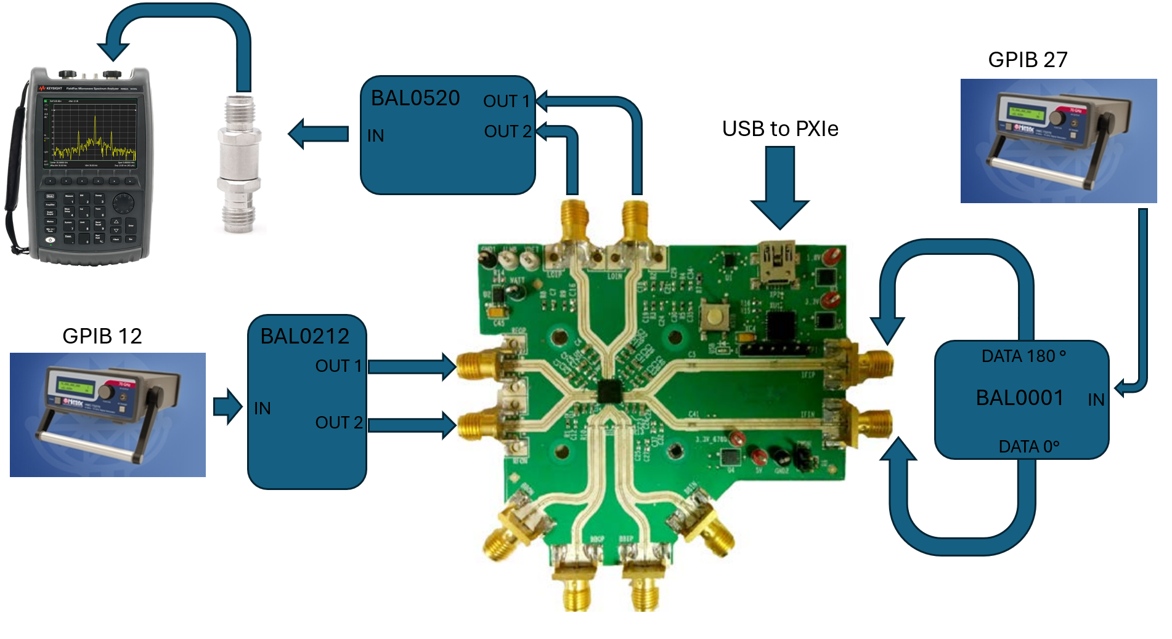
- Connect the banana jacks as follows
- Be sure to connect all ground connections together. There should be one for each card and the DUT ground (3x 4139, 1x 4163, 1x DUT).
Black GND | GND connections
Red 5v | 4 VCC (4139 card)
Orange 3.3v_6780 | 5 VCC (4139 card)
Yellow 1.8v | 6 VCC (4139 card)
Green 3.3v | CH0 (4163 card)
Blue 2.6v VATT | CH1 (4163 card)
- Open the Labview software
  - Configure the Data block as necessary
- Open the power block
Be sure to activate all channels and queue the changes
  - 4163 tab
    - Channel 0: V = 3.5v, channel name = Green 3.3v
    - Channel 1: V = 2.6v, channel name = Blue 2.6v VATT
  - Slot_4
    - Voltage = 5v, channel name = Red 5v
  - Slot_5
    - Voltage = 3.3v, channel name = Orange 3.3v_6780
  - Slot_6
    - Voltage = 1.8v, channel name = Yellow 1.8v
- Open the RF Block
  - GPIB 27
    - Name = IF, Freq = 2GHz, Power = -10dBm,
  - GPIB 12
    - Name = LO, Freq = 8GHz, Power = 0dBm
- Check unconfigured Supply Currents
- The Green 3.3v & Blue 2.6v VATT should be ~0mA
Red 5v | Orange 3.3v_6780 | Yellow 1.8v
~125mA | ~~17.5mA was 300mA on board 1 | ~0mA

- Open part in ACE, navigate to block diagram and ensure that the BB paths are switch off and the Quad Splitter Buffer is enabled as shown below. Once these selections are made, apply the changes.
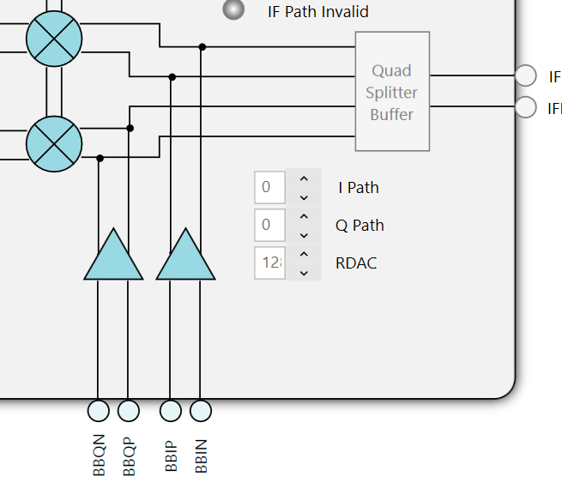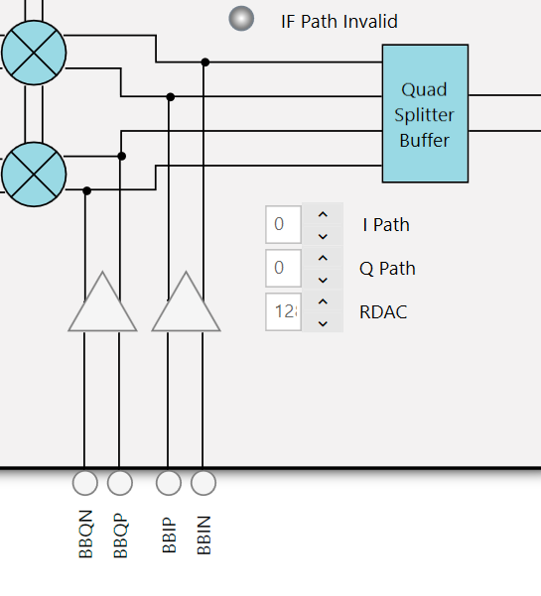
- Note the configured Supply Currents
Red 5v | Orange 3.3v_6780 | Yellow 1.8v
~122mA | ~500mA | ~0mA
- Ensure a tone is visible at 10GHz at around -27dBm
- Open the python script at the file path C:\Git\Rad-Effects-Test-Software\Python Scripts\ADRF
- Run the python script and click record data toggle in labview

